Course Name | ITD 2343 – Object Oriented Programming with C#
Instructor | Mark L. Pranger
Student Name | Lauren Lashley
Due date | March 29, 2026
Grade | <grade earned here>
Grading Comments | <instructor comments here>
Lab Portion Section 3 Exam

3 Progression Screenshots:
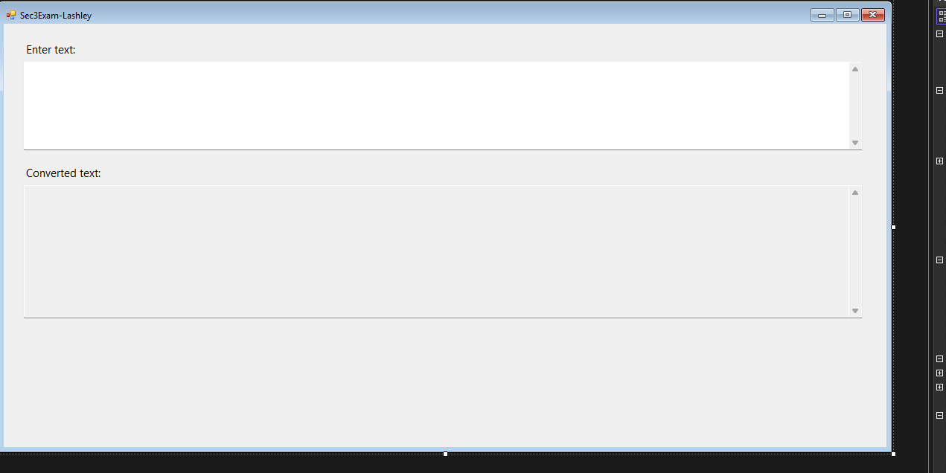

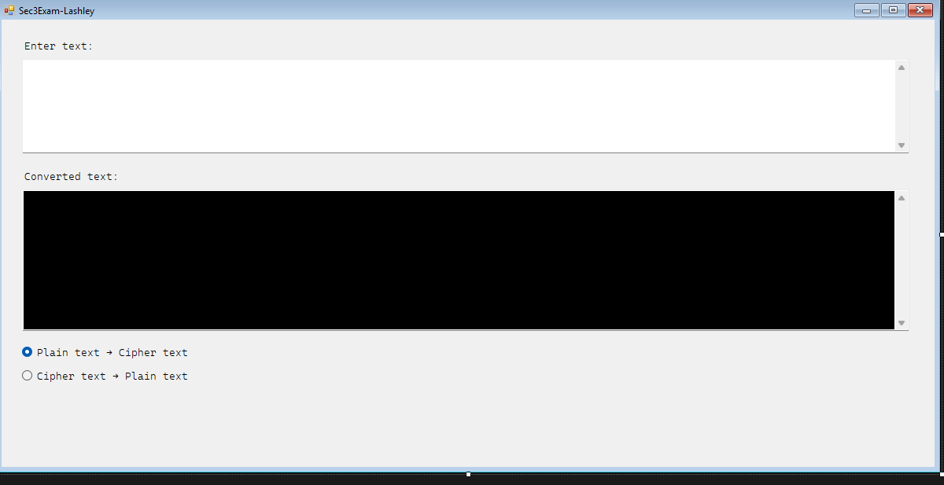
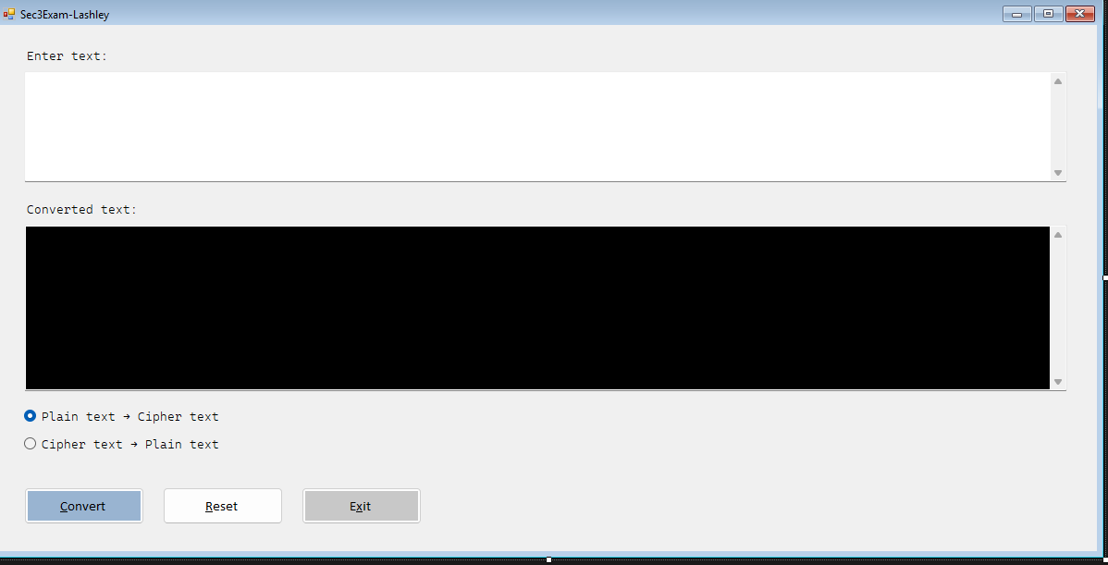

Screen shots of the form as seen when the program is executed:
- Enter your name and convert to Cipher Text:
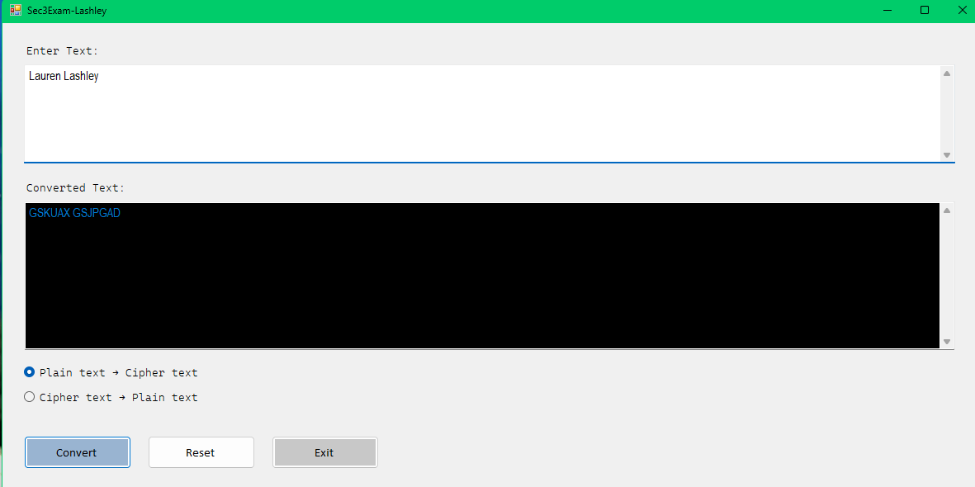

Screen shots of the form as seen when the program is executed:
- Enter Professor Greg Morris and convert it to Cipher Text:
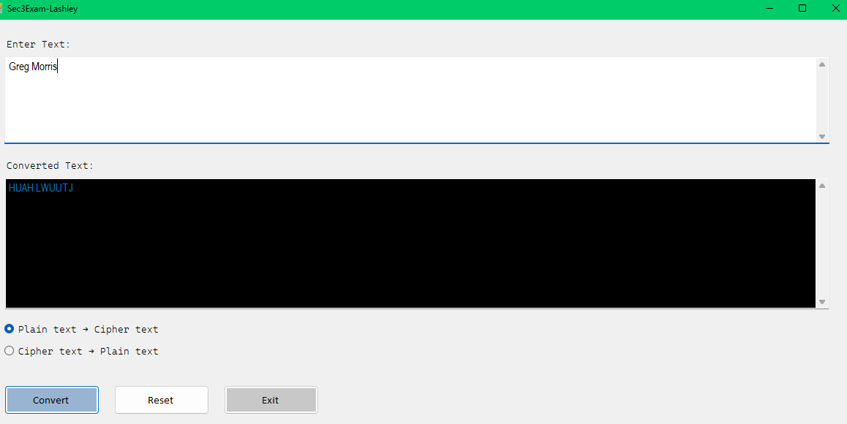

Screen shots of the form as seen when the program is executed:
- Convert the following phrase to Cipher text: Four Score and Seven Year ago:
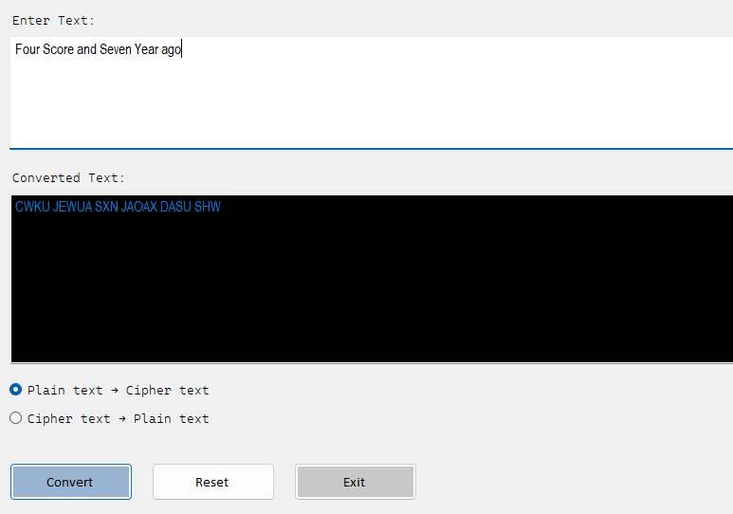
Screen shots of the form as seen when the program is executed:
- For giggles, use your name as cipher text and convert it back to plain text to see what it says:
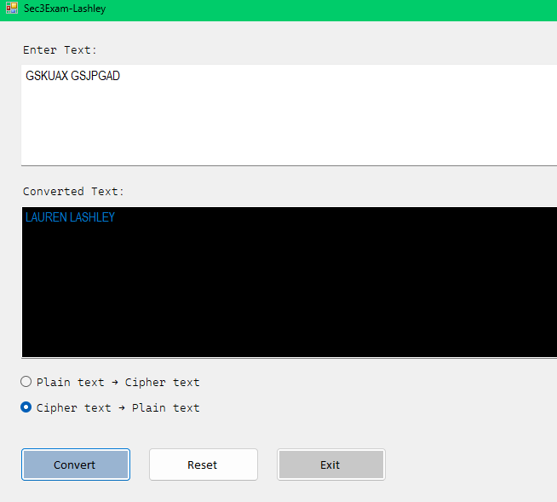

Screen shots of the form as seen when the program is executed:
- Show the plaintext of the following cipher text phrase: "HfVFo EIcN OFv oI MkX np”:
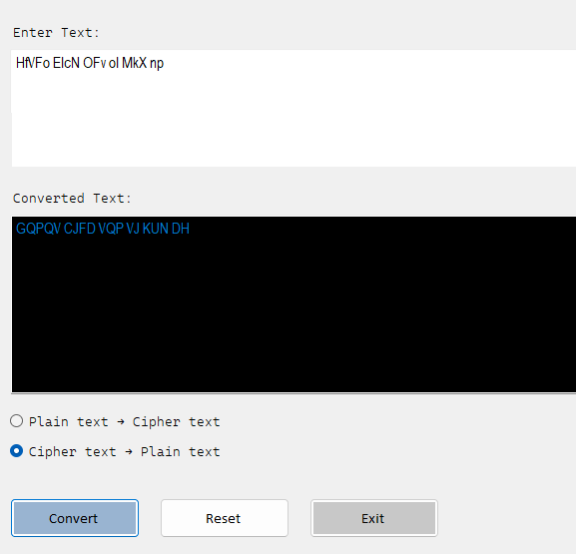

One Screen shot showing results with the following set of data being entered by the user: (error case):
- Show the error when you try and convert an empty input to cipher text:
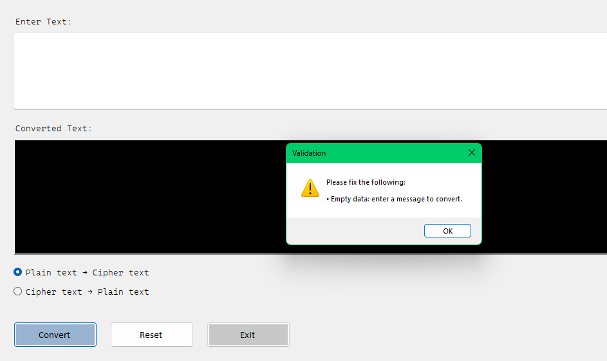

One Screen Shot showing the Message Box when you exit the application that says how many Messages were converted:
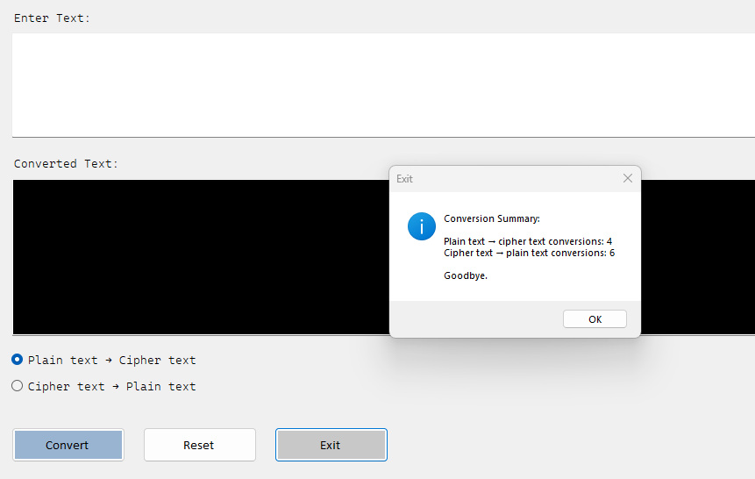

The form as it starts (Program Initiation):
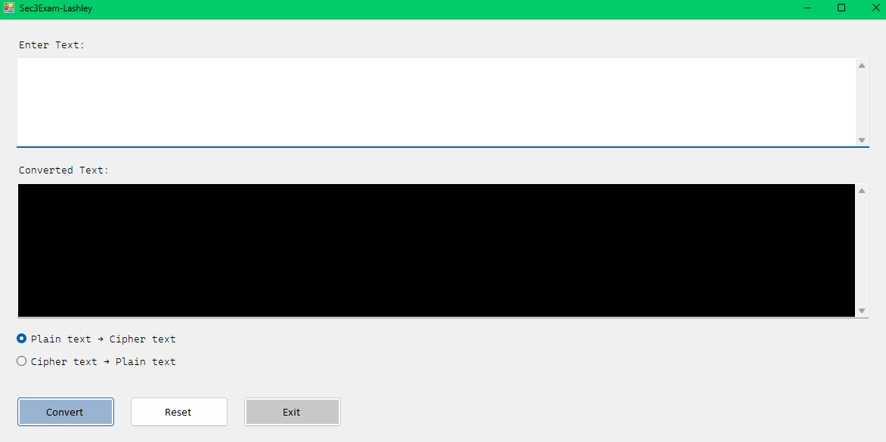

The form after the Reset button is used (Functional Operation):
Not really sure how to show the reset button works if it looks the same as the above screenshot of program initiation.


